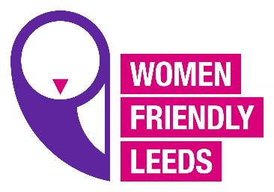

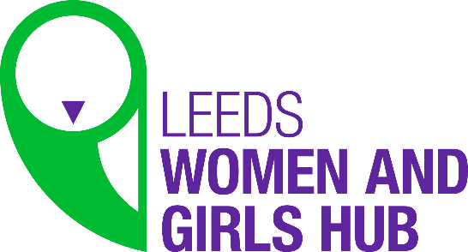
Leeds Women’s Hub Meeting Notes
9.3.21
The meeting began with a presentation from Jill from Emergency Housing, Jill covered a wide range of provision offered by Emergency Housing and in particular, Jill talked about women specific provision and what Housing Options are planning for women’s services. Jill offered to return to the Hub to follow up on developments within the service on women’s services.
AM updated the group on the IWD event “Love Yourself” and the 10 taster sessions they can choose 3 of at the event, the event was well subscribed.
ET updated on the new campaign “Shining a Light on Women’s Inequalities” #thisisournormal.
ET shared the campaign material with the group and explained what the key themes are and what we would like the women to do as part of the campaign. The key themes were Employability, Wellbeing, Flexible Health Care, Ask Us and Include Us Before You Decide. ET wanted to start a discussion to explore what the Women’s Hub would be doing to drive the campaign. A member said an organisation called Smart Works had a scheme to support women with interviews and wardrobe to help get back to work, maybe a directory of organisation who offer this support. ET said we need to ask other people to make the changes needed to support the campaign, we need some big strategic asks, another member said unless the powers that be are addressed to look into this it will challenging to make any change, over the years recommendations have been made and not been taken on, there needs to be less emphasis on finding out and more on action, for reports that have been done already, we need to find out who are the decision makers and get the messages to them. The fact that some of the issues have been raised years ago we need to follow up on these actions and find out who to target, the member said they would be happy to write a letter that can be shared with decision makers.
Could we target employers and ask employers to take the campaign on board, and ask them to commit to making some changes, another member said we could ask employers to write things into their policies, like flexible working and learning from how people have worked from home during COVID and still be effective.
Another member mentioned contacting Jobs and Skills in the council to get the campaign messages out as they have links to all the employers in the city, find out how they can support the campaign, the member had another contact they thought would be useful to speak to so she will pass their details on. ET said we could start with job adverts to standardize the experience of applying for jobs because if we can ensure flexibility in included as a standard to help women juggle multiple roles and still be effective at work.
Another member talked about including the gender pay gap and women in leadership, and look at women in leadership positions. Also to encourage organisations to look at women with additional barriers into leadership positions in work.
ET said this was a good start and some great ideas to start working with, she also went to an event where the new head of the council talked about the council stats on job roles, 51% of the top jobs in the council are held by women, but also the majority of the lower paid jobs are also held by women.
A member talked about using social media to get the messages out with very specific asks of people to support the campaigns key points. Also some members said we need to link in with other organisation around the campaign to help spread the message further.
The next key message was Wellbeing, ET talked about what came out of the Women’s Survey, like women feeling stressed and worried and not having time for themselves, also juggling multiple roles and not being supported, being expected to cope. AM mentioned a discussion in a previous meeting about groups in localities women can have access to, a member said some women lack confidence and courage to approach wellbeing services and just get on with it, and often don’t look out for themselves.
There needs to be investment in local services as women are more likely to access their craft group or health group and share if there are any issues with their mental health with the people they trust in their group rather than goring to the GP or hospital. A member said there is some funding available for services for women due to loneliness and isolation, women’s group work really well to address this, there is a need to have more groups like this. Maybe commissioners need to look at where they are funding services and maybe the campaign can target commissioners to address the distribution of funders.
The time ran out so we were not able to go through al the key messages so we will revisit them again at the next meeting.
The final point was made about the LGBTQ+ event and creating an opportunity to get feedback from participants, it would be good to get numbers which JMB said 39 people attended, ET wrote a blog about it which is out, the steering group want to come together again to plan another event for the black pride event, a member said it will be too soon to do it in June as it took a lot of planning to get the first one off the ground. ET said there are already 4 people ready to go to discuss the black pride event, and AM said she had been in discussion with some LGBTQ+ people from culturally diverse communities who want to do something.
A member suggested we have a set time in the meetings for speakers so that we have enough time for the groups discussions in the future, because the discussions are important.

