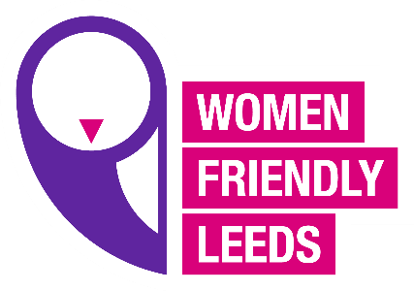

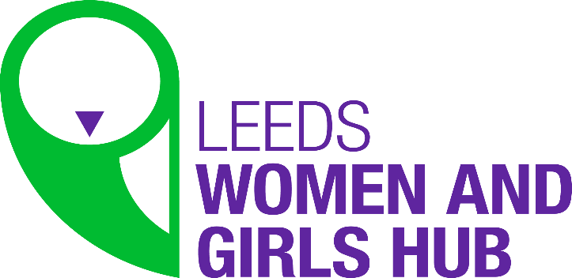

WFL Women’s Hub Notes 9. 2.21
The meeting started with a presentation from Victoria and Amy from Freedom for Girls, they shared information about the projects they are currently working on and their campaign on Period Poverty and the research they have done to highlight the issues for lots of women and girls, they have a survey they would like as many women as possible to complete and will be sharing it with us so we can send it out.
Action: AM or ET to share the link to the survey with the Women’s Hub members.
Next there was a presentation from Liz about the Termination services, Liz brought Yvonne who was a volunteer supporting the Termination service to shape their new strategy, Liz shared information about some research they did that highlighted some inequalities to accessing the service. Liz wanted to hear from the Women’s Hub members to capture their views on the procurement. Liz had some surveys to share to capture voices on women who had used Termination services, or never used them or may use them in the future.
Action: AM or ET to share the surveys with the Women’s Hub members.
Next item ET updated on the International Women’s Day event, this is going to be focused on “Self Love” there will be a selection of taster sessions women can access on the day. The event is on the 10th March at 6pm.
Women Friendly Leeds will be launching our new campaign “Shining a Spotlight on Women’s Inequalities” “This is Normal” the campaign will be launched during IWD week on the 8th March.
JH told the group about the Council’s event for IWD and asked if people were doing events they wanted to share, they should send them to AM or ET so the Council could collate them together. ET also said WFL website has a calendar and any events can be shared there.
ET updated the group on conversations that are starting on Hate Crime, and the Menopause Café that is happening on the first Wednesday of every month, let ET know if you are interested.
Also ET updated on the LGBT+ event coming up on the 24th February all are welcome.
AM updated on the Emergency Housing update and said the person could not attend the meeting this time but will be attending a future meeting.
FD updated on a project at Getaway Girls where the young women are working with animators on a piece of work around Healthy Relationships, and they will be working on a whole range of issues the young women have identified themselves.
AM said it was important for young women’s voices are captured, FD said the group who are doing the HerStory project will be meeting up as a group after the project and AM and the development workers at Vocal Girls can work together with this new immerging group.

