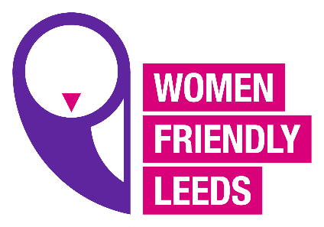
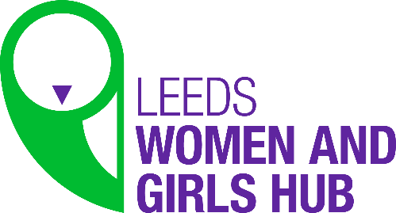

WFL Women’s Hub meeting
Agenda 13.4.21
- Welcome and introductions
- New campaign 2021 (Shining a Spotlight OnWomen’s Inequalities “This is our Normal”)
- Women’s Friday Hub (Focus Group)
- Member’s updates
- WFL updates
- Mindfulness/Inspirational moments
- AOB

