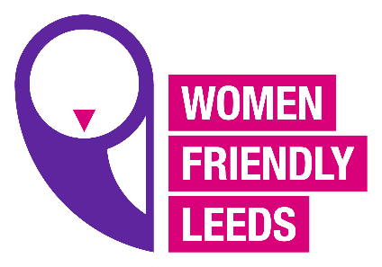
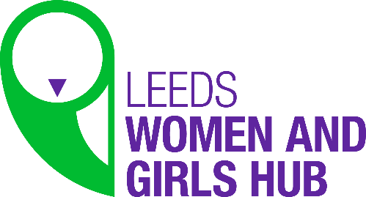

WFL Women’s Hub meeting
Agenda 9.3.21
- Welcome and introductions
- Guest Speaker Hayley Watson (RELATE)
- International Women’s Day event (Love Yourself)
- New campaign 2021 (Shining a Spotlight OnWomen’s Inequalities “This is our Normal”)
- Member’s updates
- WFL updates
- Mindfulness/Inspirational moments
- AOB

