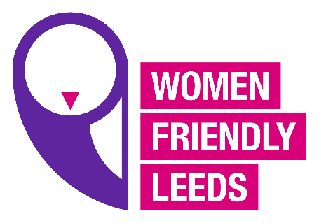
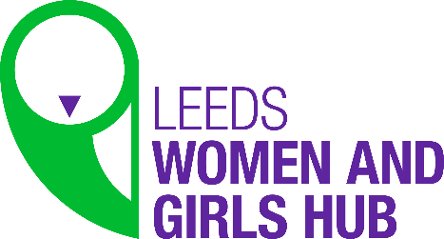
Leeds Women’s Hub notes
13.4.21
Attendees: Val, Sarah, Susan, Belinda, Iola, Vicky, Tessa, Di
WFL staff: Annette, Emily

The meeting started with a welcome and introductions, then we went straight into breakout rooms to discuss what the groups priority under the themes of the campaign would be.
The first session covered Women’s Safety.
Feedback from group one had several ideas, not just one, they talked about schools doing more around safety, also planning in the city should be looking at street lighting etc. They discussed that men should be calling out other men around women’s safety as it’s not just a woman’s responsibility to solve the problem, a member said it is possible to change the attitudes about women’s safety because they changed attitudes over other things in the past with a campaign to raise awareness, a member said they would like to see Leeds doing a big campaign around Women’s Safety.
Group 2 said their discussion was similar to group one, they said they wanted to ask men to call out men’s behaviour and ask employers to speak to the men in their organisations about supporting the campaign and talking about women’s safety. Emily updated the group on a conversation she was already having with the Men’s Health Network who were keen to support the campaign, she said they wanted to do a survey for men about women’s safety and work with us on the campaign, we could get men to send us some positive quotes about women’s safety and tweet them, and we could work alongside men for this part of the campaign. Emily asked the group if they would like her to pursue this relationship, the group agreed it was a good idea for her to go ahead. A member wanted to clarify before the next session that we were doing one theme at a time and coming up with one key issue to take forward for the campaign.
The second session was on Employability.
Group 2 fed back 3 things that should be standard in employment law and should on every job application.
- The right to work from home or office
- The right to flexible working in all industries
- Right to job share.
Group 1 fed back and shared from their group.
- In school there should be gendered education, not focusing on male or female specific opportunities.
- Looking at police recruitment to ensure equality and diversity is embedded in all recruitment campaigns.
- Ensuring all organisations in Leeds publish their gender pay information yearly in the public domain.
The third session was on Wellbeing.
Group 1 fed back on:
- The need for more provision for women, groups online and face to face with creche and expenses.
- Don’t know how accessible council services are, there are waiting lists and people don’t know how to access them. And women with a sensory impairment may need additional support to access the services, need information to be more accessible.
- Need to look at keeping the option to continue services online, COVID has forced people on line, but for some people with disabilities it has been the only way they can access services or groups, otherwise they may never have been able to attend.
Group 2 fed back on:
- Education in schools about mental health and wellbeing, people need to understand how to recognise mental health at the earliest point, and how to help themselves or someone else.
- It needs to be on the national curriculum in order to change the culture of mental health.
- So what can we do to support mental health education in schools right through to the work place?
- A question was asked in the group about the cross over of physical and mental health and should we be paying more attention to it?
The fourth session was Flexible health care options:
Group 1 fed back on:
- Creche facilities at places like gyms and health centres and other health facilities to encourage more women to attend and not make it such a barrier.
- More flexible services delivered from roving busses or pop up clinics in local areas.
- Advertising in GP services about what women are entitled to like asking for a female nurse, evening surgeries, IRIS service which trains health professionals on how to spot issues in women.
Group 2 fed back on:
- Prevention, having information early on things like menopause, and being more diverse in their approach.
- More engagement with service users to help shape services in the future, co- production is essential, the need to be more involved in shaping service with the local authority and health care.
AM told the group that the meeting has captured a lot of very useful information and will be coming back to the group with asks about how you want to take things forward.
VK Shared information on a book she has been reading online called “Invisible Women” Exposing Data Bias in a World Designed for Men by Caroline Criado Parez. It looks at things like transport and how it was designed for men, even though it’s not UK based we can learn things from it, VK will share it with AM to share with the group.

