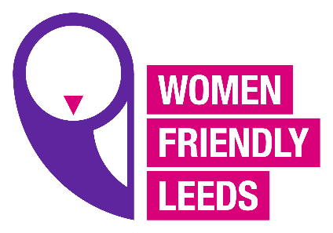

WFL Women’s Hub meeting
Agenda 11.5.21
- Welcome and introductions
- WFL updates
- New campaign update 2021 (Shining a Spotlight OnWomen’s Inequalities “This is our Normal”)
- Women’s Friday Hub update (Focus Group)
- Member’s updates
- Mindfulness/Inspirational moments (if we have time)

