**The Big Give – Women’s Night Safe Space**

**Social Media Resource Kit**

Thank you for supporting Women’s Night Safe Space as we fundraise in partnership with The Big Give. Below are resources you can copy and paste to spread the word about our campaign via social media. We appreciate your support!

Text for captions

**Instagram**:

I’m supporting the Women’s Night Safe Space’s fundraising campaign, in partnership with the Big Give! Any money raised between Midday 10th – Midday 17th October will be match-funded by The Big Give, meaning your donation makes twice the impact.

There are 2 key things you can do to support the campaign:

1. Give £1, or an amount of your choice, through the fundraising page on the Big Give website between Midday 10th – Midday 17th October
2. Spread the word and ask 5 people you know if they could also give £1 each.

The Women’s Night Safe Space provides a vital service to women and girls in Leeds City Centre every weekend, but is at risk of closure due to lack of funding. Together we can help keep this essential service running, and by donating during The Big Give week, your contribution will go twice as far!

Head to the link in @womenfriendlyleeds bio to donate!

**LinkedIn**:

I’m supporting the Women’s Night Safe Space’s fundraising campaign, in partnership with the Big Give! Any money raised between Midday 10th – Midday 17th October will be match-funded by The Big Give, meaning your donation makes twice the impact.

There are 2 key things you can do to support the campaign:

1. Give £1, or an amount of your choice, through the fundraising page on the Big Give website between Midday 10th – Midday 17th October
2. Spread the word and ask 5 people you know if they could also give £1 each.

The Women’s Night Safe Space provides a vital service to women and girls in Leeds City Centre every weekend, but is at risk of closure due to lack of funding. Together we can help keep this essential service running, and by donating during The Big Give week, your contribution will go twice as far!

Head to the fundraising page here: <https://donate.biggive.org/campaign/a056900002SEX6EAAX>

Or find out more about the vital service that the Women’s Night Safe Space provides: <https://womenfriendlyleeds.org/womens-night-safe-space/>

**Twitter/X**:

Can you give £1 to help save the Women’s Night Safe Space from closure? Any donations made between Midday 10th – Midday 17th October will be match-funded by The Big Give, meaning your contribution can have twice the impact! Head to the fundraiser here: <https://donate.biggive.org/campaign/a056900002SEX6EAAX>

**Image for all social posts:**

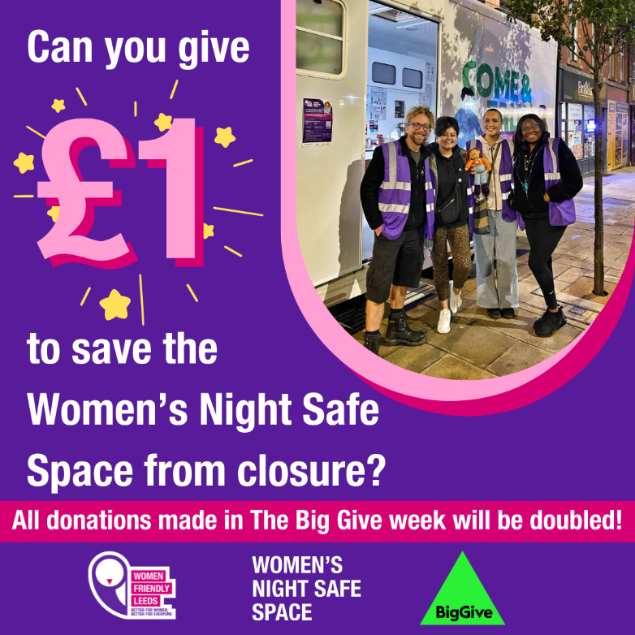

**Alternative Image for Social Posts:**

